MATH 45 REVIEW EXAM 3 SPRING 2021 (Section4.6,7.1,7.2)

Q1. Solve ( using Variation of Parameters) y” + y = Sin x

1

Ans : y = c1 Cos x + c2 Sin x -

2

x Cos x

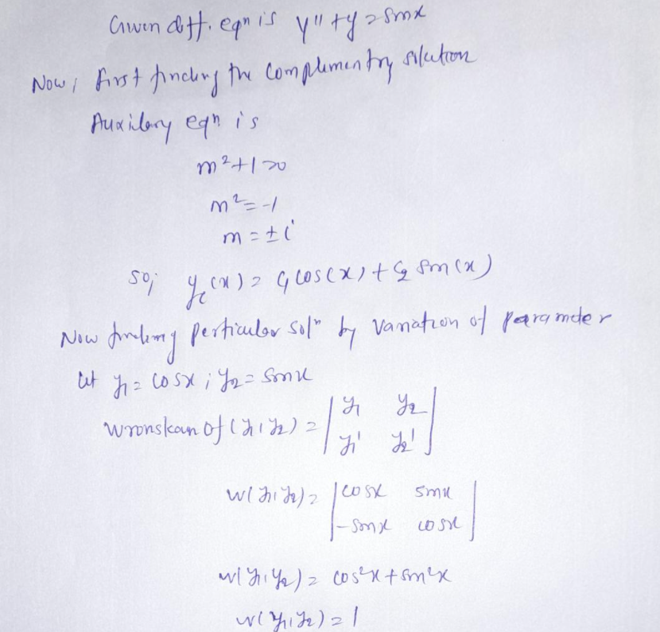

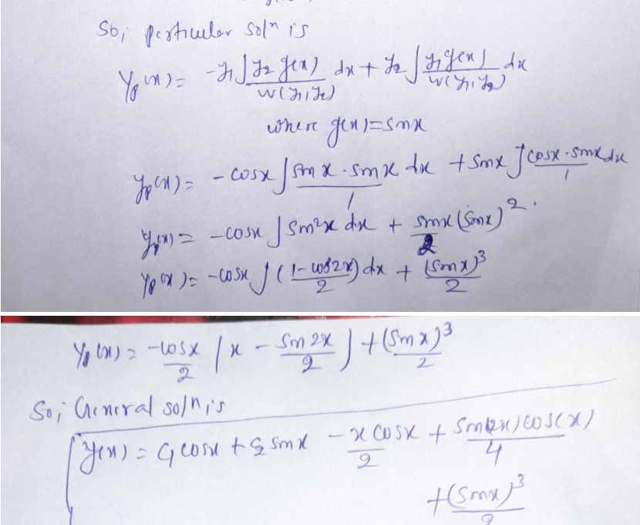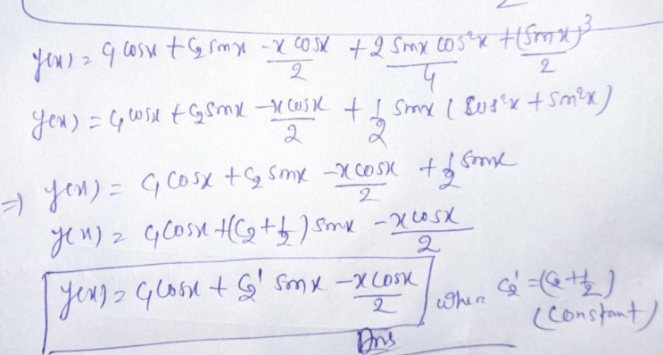

Q2 .Find L [ f( t) ] , f( t) = e- t Sin t Ans : 1

2

s +2s+2

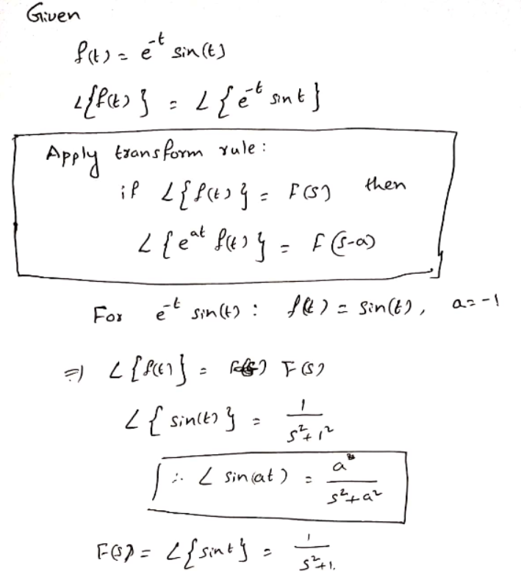 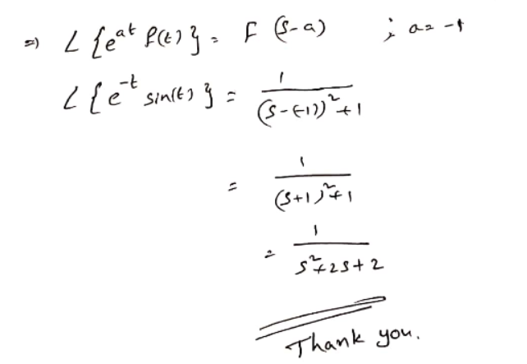

Q3. Find L -1 Ans : - 2Cos 2t + 3 Sin 2t

− 2𝑠+6

𝑠2 +4

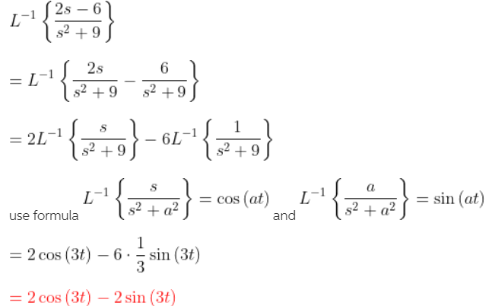

Q4. Solve the given differential equation by using Laplace transform:

Y” - 6 y ’ + 13y = 0 y (0) = 0 , y’ (0) = - 3 Ans : (- 3 e3t sin 2t )/ 2

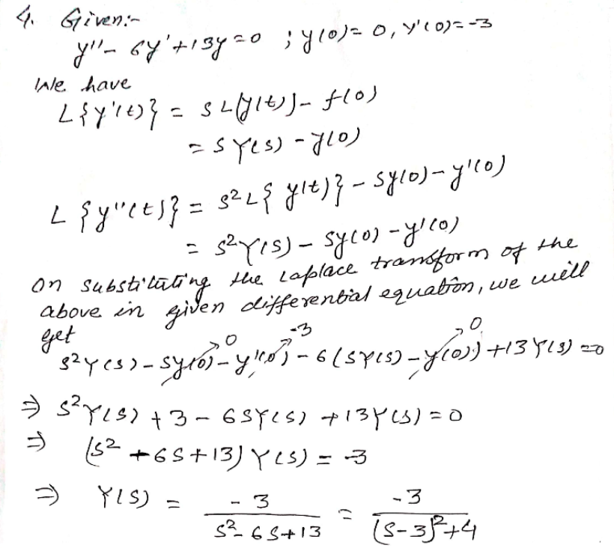

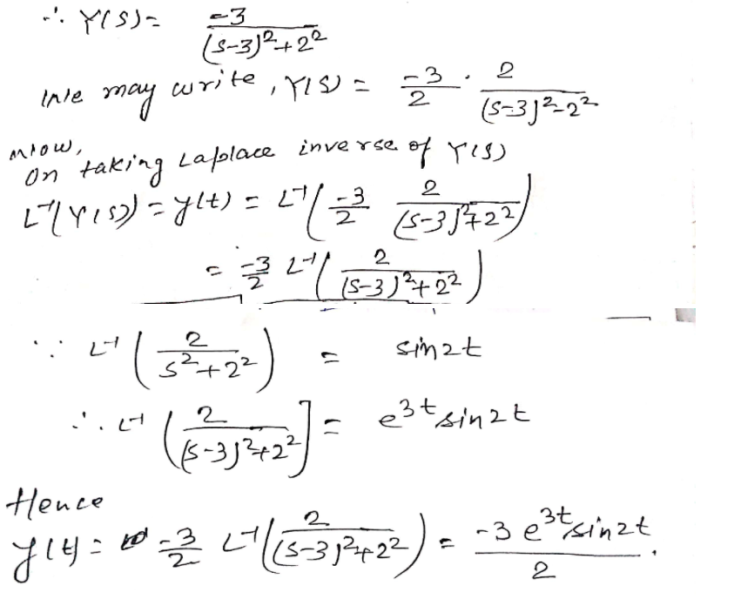

Q5. 

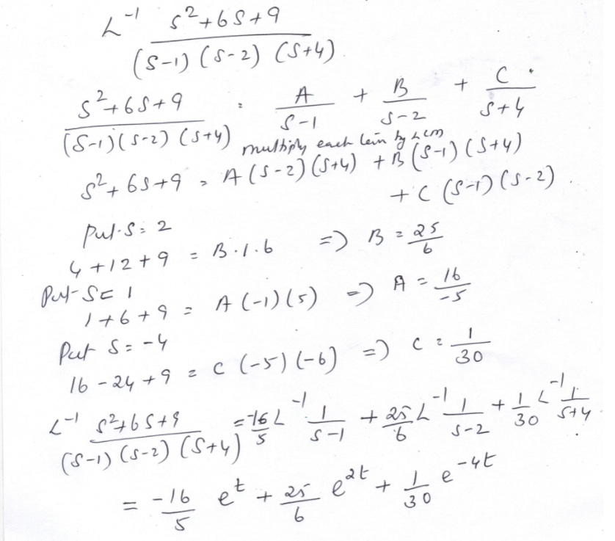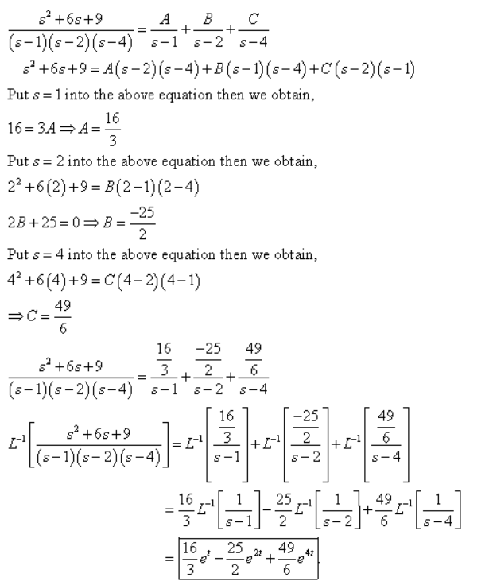

Q6. Solve y” +4y’ +6y = 1+e-t , y(0)= 0 , y’(0) = 0 

